David M. Lawrence and Chris French
ENVS 691 Laboratory Exercise No. 3, Redux

End-Member Mixing Analysis

Introduction
An end-member mixing analysis was preformed on the tidal James River utilizing a simple spreadsheet model. This analysis was performed on chemical constituents obtained from Virginia Department of Environmental Quality water monitoring stations in the James River estuary. This exercise focused on total dissolved phosphorus (TDP) and chlorophyll a (Chl a) in 12 monthly samples obtained in the 2002 calendar year.

Methods
The water quality parameters selected were chosen due to the eutrophication issues that have been observed in the tidal James River. The model uses observed salinity values to estimate nutrient and other constituent gradients assuming conservative mixing in the estuary. Observed values of TDP and Chl a were compared to predicted values. Small differences between predicted and observed values indicate the model behaves conservatively while larger values would indicate non-conservative behavior. This can vary both longitudinally in the estuary on any given sample date as well as throughout the year at a specific monitoring site. This is represented graphically in Figure 1.
Some of the data are incomplete: the Feb. 19 sample is missing one Chl a observation from Buoy 166 (Mile 104), the Apr. 16 sample is missing Chl a observations from buoys 91 through 166 (miles 69 through 104), and the Dec. 12 sample is missing all observations from the mouth of the James River (Mile 0). Most of the samples did not affect the computations of the analysis, but the Dec. 12 analysis required the use of data from Buoy 9 (Mile 6) as the marine end member. The only sample seriously affected by the missing data was the Apr. 16 sample.

Results and Discussion
This exercise assumes Chl a is a proxy measure for phytoplankton populations. Given that phytoplankton demand for nitrogen and phosphorus may be driven by biological demand, Chl a concentrations are plotted along with phosphorus concentrations. These results are plotted in Figure 1.
The results show that none of the constituents are conservatively mixed. There appears to be a strong seasonal effect in Chl a concentrations, with highest values in the period from June to September. Bukaveckas et al., ((2011)) reported a similar seasonal pattern. Geographically, the peak in Chl a is near buoys 91 and 107 (miles 69 and 75), where the basin morphology of the James begins to change from a relatively narrow, deep channel to one where the channel, while still relatively deep, is flanked by extensive shallow areas toward either bank. This facilitates greater average penetration of sunlight into the water column and fuels extensive phytoplankton production (Bukaveckas, et al., 2011). Additionally, the high concentration of industry in this area likely contributes to elevated levels of Chl a.
Bukaveckas et al., (2011) report that nitrogen and phosphorus concentrations tend to be lower in the vicinity of the Chl a maximum. The 2002 data presented here seem to better support the notion that the concentrations of both nutrients show a rapid decrease in the vicinity of the Chl a maximum, but that seasonal—and arguably annual—variability affects the pattern.
REFERENCES

Bukaveckas, P., Barry, L., Beckwith, M., David, V., & Lederer, B. (2011). Factors Determining the Location of the Chlorophyll Maximum and the Fate of Algal Production within the Tidal Freshwater James River. Estuaries and Coasts, 34(3), 569-582. doi: 10.1007/s12237-010-9372-4

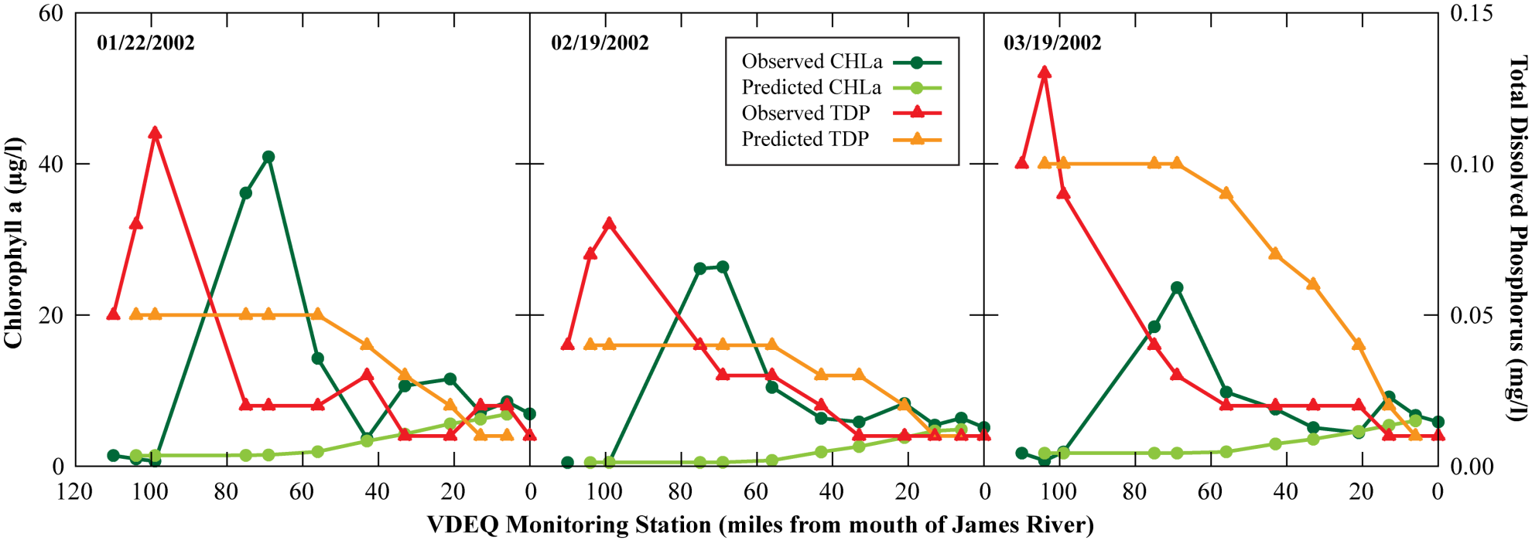

Figure 1a. Results of end-member mixing analyses of chlorophyll a (µg l⁻¹) and total dissolved phosphorus (mg l⁻¹) in monthly water samples from a transect along the James River in 2002.

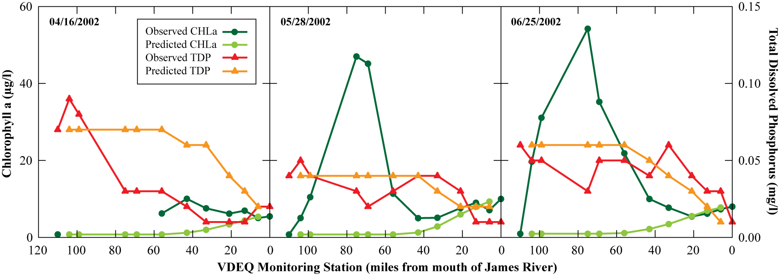

Figure 1b. Results of end-member mixing analyses of chlorophyll a (µg l⁻¹) and total dissolved phosphorus (mg l⁻¹) in water samples from a transect along the James River in 2002.

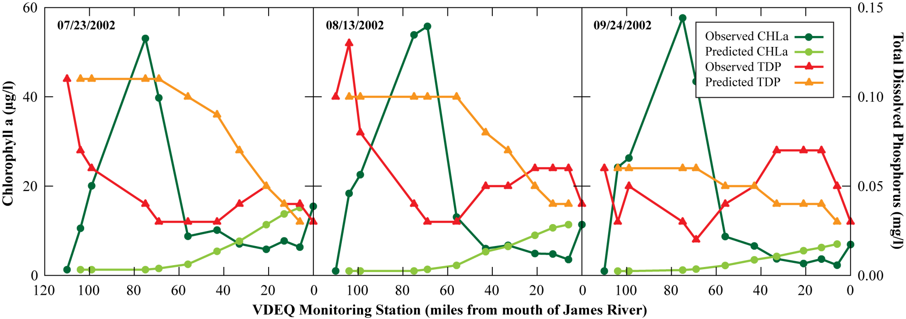

Figure 1c. Results of end-member mixing analyses of chlorophyll a (µg l⁻¹) and total dissolved phosphorus (mg l⁻¹) in water samples from a transect along the James River in 2002.

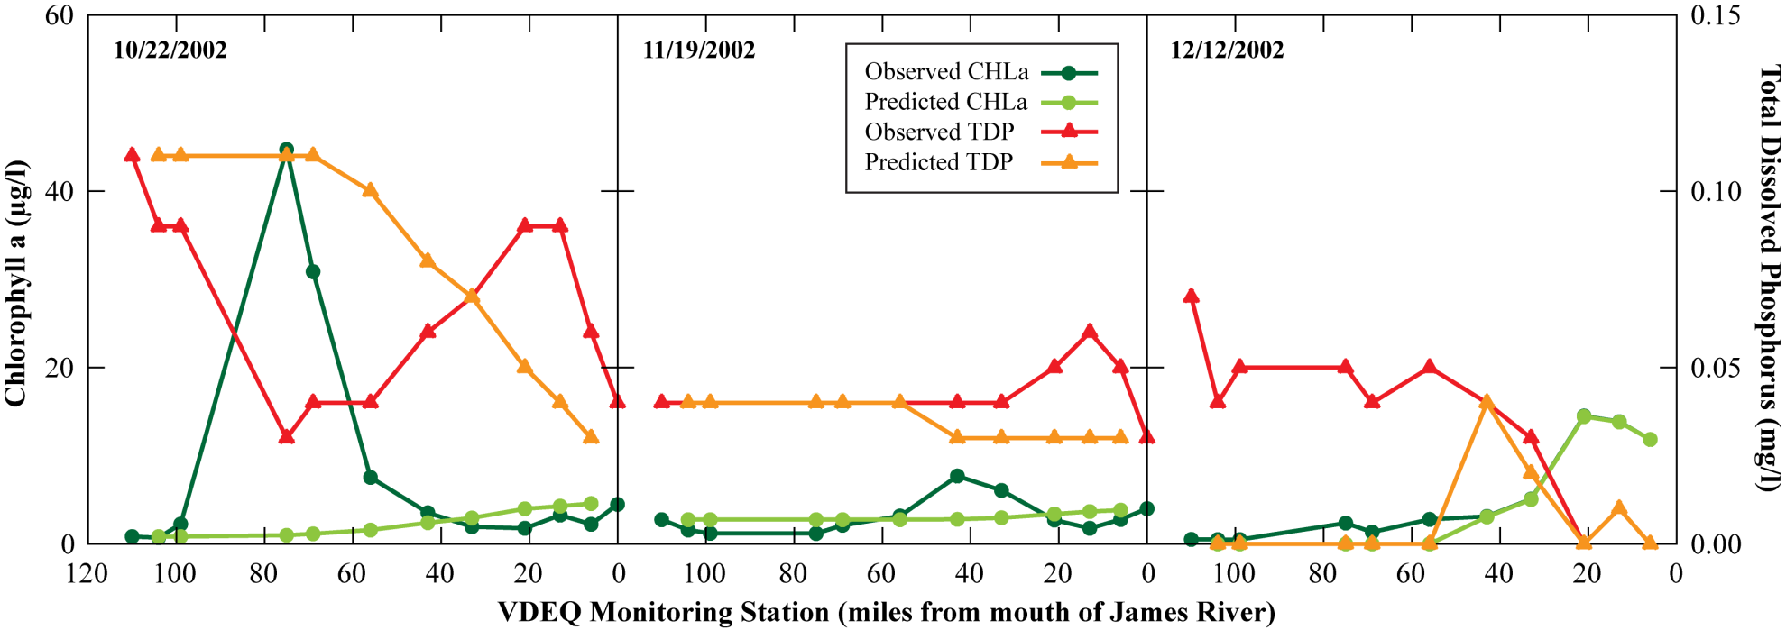

Figure 1d. Results of end-member mixing analyses of chlorophyll a (µg l⁻¹) and total dissolved phosphorus (mg l⁻¹) in water samples from a transect along the James River in 2002.

